LAB REPORT –4
Programmable ALU

Name:Basireddy Khyathi Sri
Roll Number: 2023102065
Group Number: 6
Table : 3

Objective:
To create an arithmetic and logic unit (ALU) that can execute
8 different arithmetic operations on 1-bit operands.

Electric Components Required:
- Breadboard
- LED display bulbs
- Arduino UNO R3
- Two 8:1 MUXes (IC 74151),
- Four ICs -one consisting of AND (7408), one of OR (7432), one of XOR (7486), one of NOT gates (7404)
Note : In the lab instead of gates mentioned in (5) we have used a 2:1 MUX (IC 74157), XOR gate(IC 7486).
6)Connecting Wires
7)Resistor

Reference Circuit :
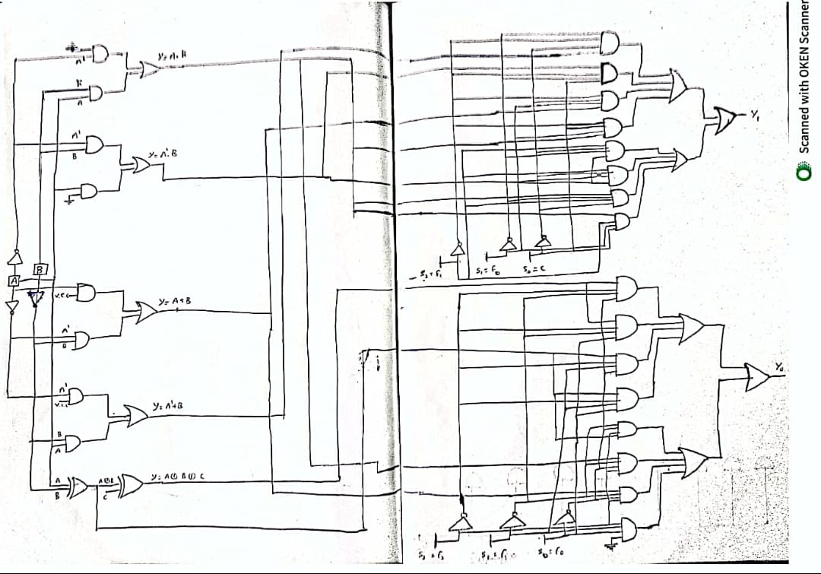

TinkerCad Simulation:

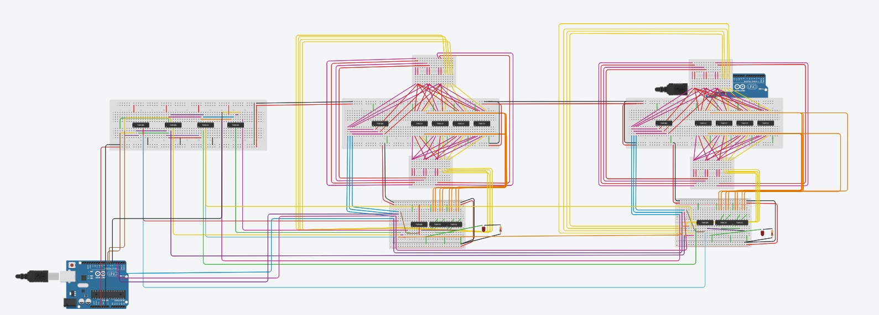

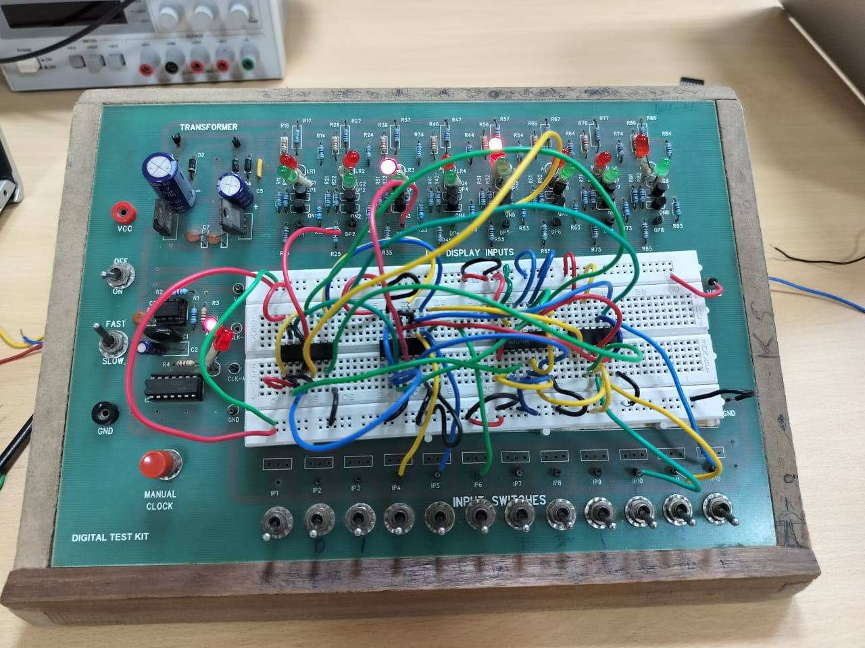

CODE:
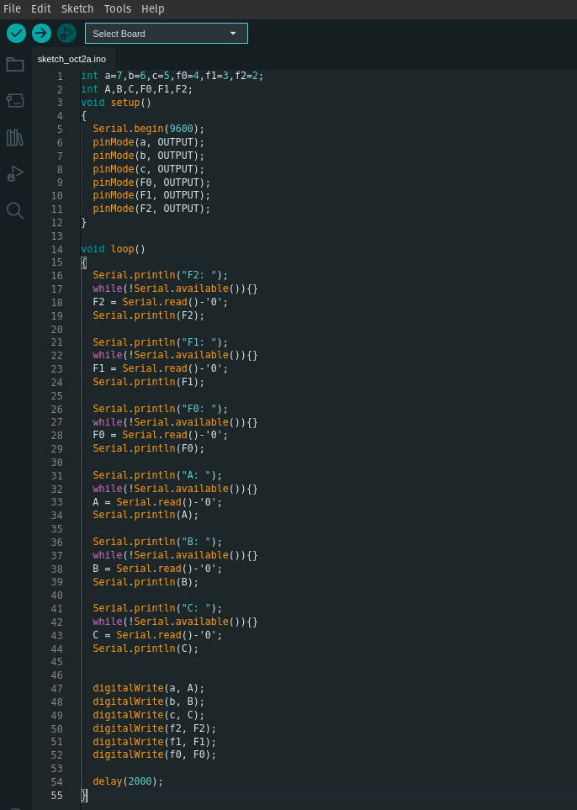

Procedure:
1. Turn on all of the breadboards by attaching their +/- columns to the VCC and GND pins on the Arduino board.

2. Connect the breadboard's VCC and GND to the two 8:1 MUXes (MUX0, MUX1).

3. For the inputs of both MUXes, we must perform the binary operations listed in the reference circuit.

4.The ICs required for AND, OR, NOT, and XOR operations should be placed.

5. For inputs A, B, C, F2, F1, and F0, we must use the serial monitor on the Arduino.

6. Now that the Arduino inputs are connected to the ICs, we can perform the binary operations between A and B as shown.

7. After that, connect the gates' outputs to the respective MUX input ports.

8. The select lines for MUX0 are F0, F1, and F2, whereas the choose lines for MUX1 are C, F0, and F1.

9. To ensure that MUX0 is constantly operational, we must link the enable of MUX0 to the VCC.

10. For it to function, F2 must be connected to MUX1 in the enable position.

11. Apply each combination input (F2, F1, F0) individually for combinations of data inputs A, B, and C, and tabulate the observed outputs, Y0 and Y1.

Observation:
After applying combinations of A,B,C; the output values are
tabulated below for each combination of select lines F0,F1,F2.

(0,0,0)
A | B | C | Y1 | Y0
0/1 | 0/1 | 0/1 | - | 0
Y1 = “-”
Y0= 0

(0,0,1)
A | B | C | Y1 | Y0
0 | 0 | 0/1 | - | 0
0 | 1 | 0/1 | - | 1
1 | 0 | 0/1 | - | 1
1 | 1 | 0/1 | - | 1
Y1=”-”
Y0 = A+B

(0,1,0)
A | B | C | Y1 | Y0
0 | 0 | 0/1 | - | 0
0 | 1 | 0/1 | - | 0
1 | 0 | 0/1 | - | 0
1 | 1 | 0/1 | - | 1
Y1 = “-”
Y0 = A.B

(0,1,1)
A | B | C | Y1 | Y0
0 | 0 | 0/1 | - | 0
0 | 1 | 0/1 | - | 1
1 | 0 | 0/1 | - | 1
1 | 1 | 0/1 | - | 0
Y1 = “-”
Y0 = A^B

(1,0,0) A+B
A | B | C | Y1 | Y0
0 | 0 | 0/1 | 0 | 0
0 | 1 | 0/1 | 0 | 1
1 | 0 | 0/1 | 0 | 1
1 | 1 | 0/1 | 1 | 0
Y1 = Carry
Y0 = Sum

(1,0,1) A - B
A | B | C | Y1 | Y0
0 | 0 | 0/1 | 0 | 0
0 | 1 | 0/1 | 1 | 1
1 | 0 | 0/1 | 0 | 1
1 | 1 | 0/1 | 0 | 0
Y1 = Borrow
Y0 = Difference

(1,1,0) A + B + C
A | B | C | Y1 | Y0
0 | 0 | 0 | 0 | 0
0 | 0 | 1 | 0 | 1
0 | 1 | 0 | 0 | 1
0 | 1 | 1 | 1 | 0
1 | 0 | 0 | 0 | 1
1 | 0 | 1 | 1 | 0
1 | 1 | 0 | 1 | 0
1 | 1 | 1 | 1 | 1

Y1 = Carry
Y0 = Sum

(1,1,1) A - B - C
A | B | C | Y1 | Y0
0 | 0 | 0 | 0 | 0
0 | 0 | 1 | 1 | 1
0 | 1 | 0 | 1 | 1
0 | 1 | 1 | 1 | 0
1 | 0 | 0 | 0 | 1
1 | 0 | 1 | 0 | 0
1 | 1 | 0 | 0 | 0
1 | 1 | 1 | 1 | 1

Y1 = Borrow
Y0 = Difference

Conclusion:
All the truth tables of every possible combinations are
tabulated above; and are verified to respective operation.

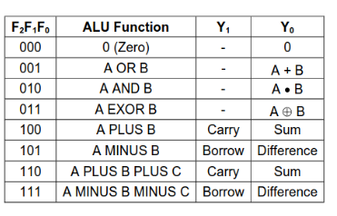
TinkerCad Link:
https://www.tinkercad.com/things/3y3bSgD00Tj-lab-5-alu/editel?sharecode=swByYLp-jLvboKV1zLThjTl98-TwO3CNQotK4A80kDI

